**CSC 2233 Database Homework #1**

**Spring 2019**

Construct an E-R diagram for a car-insurance company whose customers own one or more cars each. Each car has associated with it zero to any number of recorded accidents

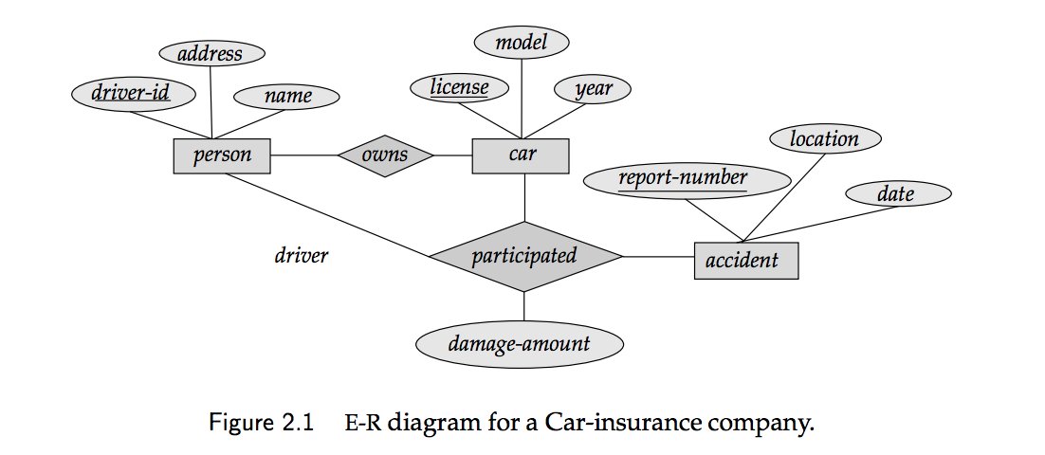

|  |  |  |
| --- | --- | --- |
| **Overview layout of Entity Sets, Relationship Sets, and additional components, per diagram** | | |
| **Name** | **Entity/Relationship Set** | **Type** |
| Person | Entity Set | Strong entity set |
| Car | Entity Set | Strong entity set |
| Accident | Entity Set | Strong entity set |
| Owns | Relationship Set | Many-to-Many, between   * Person * Car |
| Participated | Relationship Set | Many-to-Many, between   * Person * Car * Accident   With a descriptive attribute of *damage-amount* |

**Entity Sets and Relationship Sets, Broken Down**

**Entity Set *Person***

|  |  |  |
| --- | --- | --- |
| **Attributes** | **Attribute Type** | **Description** |
| driver_ID | Simple and Primary Key | Driver ID |
| address | Composite | Driver’s address with street, city, state, and zip as components |
| name | Composite | Driver’s name with firstname, middlename, and lastname as components |

**Entity Set *Car***

|  |  |  |
| --- | --- | --- |
| **Attributes** | **Attribute Type** | **Description** |
| license | Simple and Primary Key | Vehicle license ID |
| model | Composite | Car’s model with make, model and color as components |
| year | Simple | Car’s year of manufacture |

**Entity Set *Accident***

|  |  |  |
| --- | --- | --- |
| **Attributes** | **Attribute Type** | **Description** |
| report_ID | Simple and Primary Key | Report Number ID |
| location | Composite | Location of accident with street, city, state, and zip as components |
| date | Simple | Date the accident occurred |

**Relationship Set *Owns***

|  |  |  |
| --- | --- | --- |
| **Attributes** | **Attribute Type** | **Description** |
| driver_ID | Foreign Key | Primary Key of Entity Person |
| license | Foreign Key | Primary Key of Entity Car |

**Relationship Set *Participated***

|  |  |  |
| --- | --- | --- |
| **Attributes** | **Attribute Type** | **Description** |
| driver_ID | Foreign Key | Primary Key of Entity *Person* |
| license | Foreign Key | Primary Key of Entity *Car* |
| report_ID | Foreign Key | Primary Key of Entity *Accident* |
| damage_amount | Simple | The total cost of the damage that occurred during the accident |

**Final Relational Schema as follows: (keys are underlined)**

* **Person (driver_ID, street, city, state, zip, firstname, middlename, lastname)**
* **Car (license, make, model, color, year)**
* **Accident (report-number, street, city, state, zip, date)**
* **Owns (driver_ID, license)**
* **Participated (driver_ID, license, report-number, damage-amount)**

**Create a database from the E-R above. Insert some data into the tables and perform the following queries:**

**Queries are available in a file that will be named “QueryX.sql” where X is the number from the list below.**

1. **select person info given driver_id**
2. **select person_info given last_name**
3. **select person info living in California**
4. **select all the cars**
5. **select all cars >=2010**
6. **select all BMW cars**
7. **select all BMW cars with their owners**
8. **select how many accidents happened in this year**
9. **select how many accident happened last month**
10. **select all the accidents with BMW cars**
11. **select total damage_amount last year**
12. **select total damaged_amount with BMW cars**
13. **select all driver_id that had accidents last month**